**Margaret Hamilton**

Biography by **Cian O’Gorman**

Student I.D: **19334475**

Email:[**ciogorma@tcd.ie**](mailto:ciogorma@tcd.ie)

**Early Life & Education**

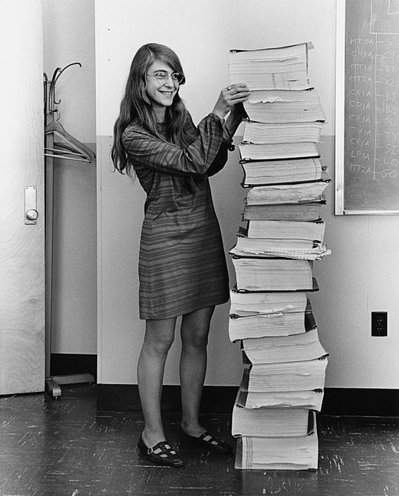

Margaret Hamilton standing beside the code her team wrote for the Apollo 11 mission circa 1969.  
[This Photo](https://nl.wikipedia.org/wiki/Margaret_Hamilton) by Unknown Author is licensed under [CC BY-SA](https://creativecommons.org/licenses/by-sa/3.0/)

Margaret Heafield was born August 17, 1936 in Indiana, USA. When Margaret graduated from Hancock High School in 1954 she studied mathematics at the University of Michigan in 1955 before transferring to Earlham College, Indiana. She earned a BA in Mathematics with a minor in Philosophy in 1958. While in Earlham College, Margaret met her first husband, James Hamilton who was majoring in chemistry. They married the Summer after she graduated from Earlham. She taught Mathematics and French at a public school while her husband completed his degree. They then moved to Boston. The couple divorced in 1967 and Margaret then met Dan Lickly in 1969.

She intended to enroll in abstract mathematics while in Boston. In the summer of 1959, Hamilton instead began working in the meteorology department at MIT. She developed software for predicting weather, programming on the PDP-1 and the LGP-30 computers. At the time, Computer Science and Programming were not formal disciplines, Computer Scientists instead learned while on the job.

**SAGE Project**

From 1961 - 1963, Hamilton worked on the Semi-Automatic Ground Environment (SAGE) Project at MIT, where she was one of the programmers who wrote software for the prototype AN/FSQ-7 computer, used by the U.S. Air Force to search for enemy aircraft. She also wrote software for a satellite tracker at the Air Force’s Cambridge Laboratories. The SAGE Project was an extension of Project Whirlwind, started by MIT to create a computer system that could predict weather systems and track their movements using simulators. SAGE was soon developed for military use in anti-aircraft air defence.

Her work on this project highlighted her as an ideal candidate at NASA for the development of space flight software.

**Draper Laboratories**

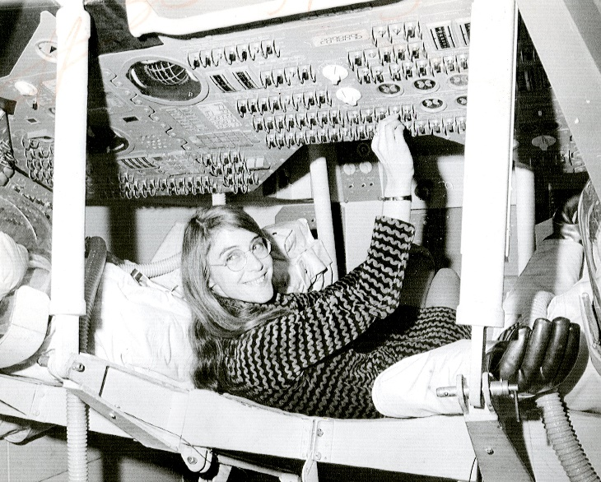

Margaret Hamilton inside a test cockpit module for the Apollo 11 mission.   
[This Photo](https://commons.wikimedia.org/wiki/File:Margaret_Hamilton_in_action.jpg) by Unknown Author is licensed under [CC BY-SA](https://creativecommons.org/licenses/by-sa/3.0/)

After working on the SAGE Project, Hamilton joined Draper Laboratories at MIT which worked on the Apollo space mission. After working as a programmer here she was eventually put in charge of all Command Module Software, this includes software for navigation and lunar landing. A part of Hamilton’s team developed system’s software. This includes error detection software such as restarts and Priority Displays. Hamilton also served as the director of the Software Engineering Division during her time at Draper.

Her areas of expertise included System design and software development techniques; enterprise and process modelling; preventative systems design and development paradigm; formal systems modelling languages; System Oriented Objects for systems modelling and development; automated life cycle environments; methods for maximizing software reliability; methods for maximizing reuse; domain analysis; correctness by built-in language properties; open architecture techniques for robust systems; full life cycle automation; quality assurance; seamless integration; asynchronous, distributed processing systems; error detection and recovery techniques; machine interface systems; operating systems; end to end testing techniques; and life cycle management techniques.1

**Apollo Program**

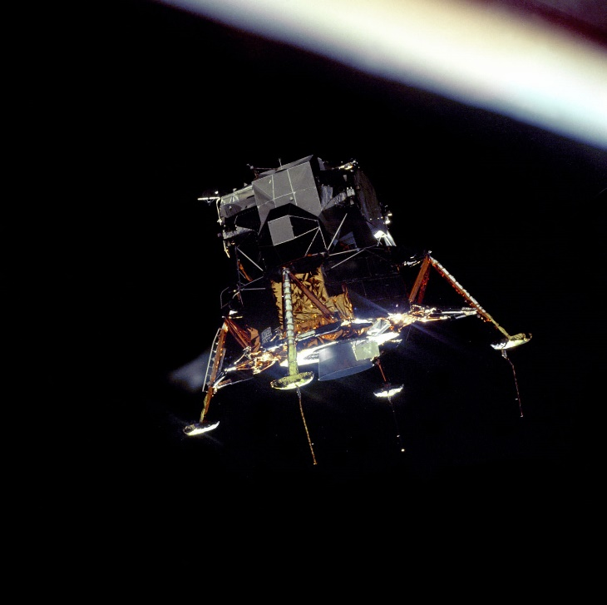

The apollo 11 ‘Lunar lander’ in orbit.   
[This Photo](https://www.universetoday.com/51531/apollo-11-pictures/) by Unknown Author is licensed under [CC BY](https://creativecommons.org/licenses/by/3.0/)

During the Apollo 11 mission, the Apollo guidance computer averted a landing on the moon, three minutes before the space craft had reached the surface of the moon, several alarms were triggered. The lunar lander’s software captured these alarms and displayed them to the astronauts using priority alarm displays. This is a situation that Hamilton had prepared for three years before.

Hamilton's priority alarm displays interrupted the astronauts' normal displays to warn them that there was an emergency "giving the astronauts a decision on what they should do next. a NASA computer engineer in mission control, recognized the meaning of the errors that were presented to the astronauts by the priority displays and shouted, "Go, go!" and they continued to land.2

**Impact**

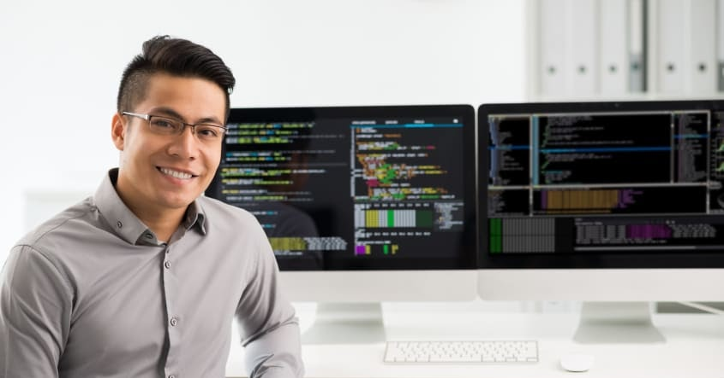

A modern day software engineer in front of their work station.  
[This Photo](https://scherlund.blogspot.com/2020/08/the-ultimate-guide-to-becoming-software.html) by Unknown Author is licensed under [CC BY](https://creativecommons.org/licenses/by/3.0/)

The term ‘software engineering’ is credited partially to Margaret Hamilton. When she first came up with the term, no one had heard of it; and it was considered an ongoing joke. Software engineering was not taking seriously compared to other forms of engineering during the time of the Apollo missions. Overtime the term gained a similar respect to other engineering disciplines partially thanks to the work of Margaret Hamilton during the Apollo missions. If it was not for her software, the mission may have potentially failed. However, Hamilton has done more for software engineering than just putting a man on the moon. At MIT she assisted in the creation of the core principles in computer programming as she worked with her colleagues in writing code for the world's first portable computer.3

**Sources:**

1. About Margaret Hamilton:

<https://web.archive.org/web/20101206145513/http://klabs.org/home_page/hamilton.htm>

2. Recalling the Giant Leap:

<https://news.mit.edu/2009/apollo-vign-0717>

3. Wired interview with Margaret Hamilton:

<https://www.wired.com/2015/10/margaret-hamilton-nasa-apollo/>

